Series Big Idea: Who is Jesus, and who are we because of Him?

Today’s Big Idea: Share the Gospel

Leader Reminders:
- Who in your life is God calling you to share the Gospel with? Make sure you are living out the things you are instilling into your students. Ask God to give you an opportunity to talk about Jesus with someone who isn’t a Christian and obey when He does.
- Pray for your students by name. Remember to be praying for the prayer requests they have shared at small group.
- Remember to let students do 70 to 80% of the talking. Resist the urge to always share your point of view on every question. Instead, use questions to guide students toward the points you want to make from the Word.
- Continue to read through Mark with your students. Keep a journal of the things that God speaks to you personally during your time with Him.

Ice Breakers:
- Share any announcements
- Ball/Hot Seat
- Happy, crappy, God moment
- Prayer requests and praises
- Follow up on “The Other Six” devotional
- Recap the study so far. How have you grown closer to Jesus?

Starter Questions: As always, have a student pray for the requests and to open your small group discussion and study time.

- What do you talk about most? Family? Friends? Celebrity crush, Netflix shows, drama at school?
- Agree or disagree ... you talk about most what you care about most.

Digging Into the Word: Have a student read Mark 6:6b–12.
- Why did Jesus want His disciples to go to other towns and share the Gospel? Isn’t it wrong to force your beliefs on other people?
- Why do you think following Jesus should be personal but not private?
- Jesus’ ministry only lasted three years. How prepared do you think the disciples felt at this point to share the Gospel and heal people in Jesus’ name? What fears do you think they had? Why didn’t Jesus just do it Himself?
- What are your biggest fears in sharing the Gospel with other people?

Have a student read John 6:44.

- Why should this verse embolden us to talk about Jesus? Why does it take the pressure off of us “doing it right”? How does the Holy Spirit affect the way you share Jesus with others?

Have a few students read Romans 8:11, John 14:12, Matthew 5:10-12

- Have you ever been rejected for sharing your faith?
- How is it possible that Jesus said we would do even greater things than Him?

Have a few students read Romans 8:11, John 14:12, Matthew 5:10–12.
- What do these passages tell us the level of importance is in sharing the Gospel?
- Have you ever shared your faith? Tell us about a time when you did.

Wrapping It Up:

Application Questions:

- If I asked you to share Jesus with me, what would you say and do?
- Based on what we read about Jesus, what would you add to what you already know about who Jesus is?
- How does what we studied show you who you are because of Jesus?
- Who is one person you want to pray for and share the Gospel with?

Prayer Partners & Activity: Break students into pairs to pray for their lost family and friends, and to practice sharing the Gospel with each other. Give them each a handout and have them use one of the two amazing resource links below to learn what the Gospel is. We want them to ...

- Depend on the Holy Spirit.
- Know the Gospel for themselves.
- Love people and invite them to “come and see” Jesus.
- Share their story of how Jesus has changed their life

https://www.dare2share.org/resources/free-teen-resources/

https://www.navigators.org/resource/one-verse-evangelism/
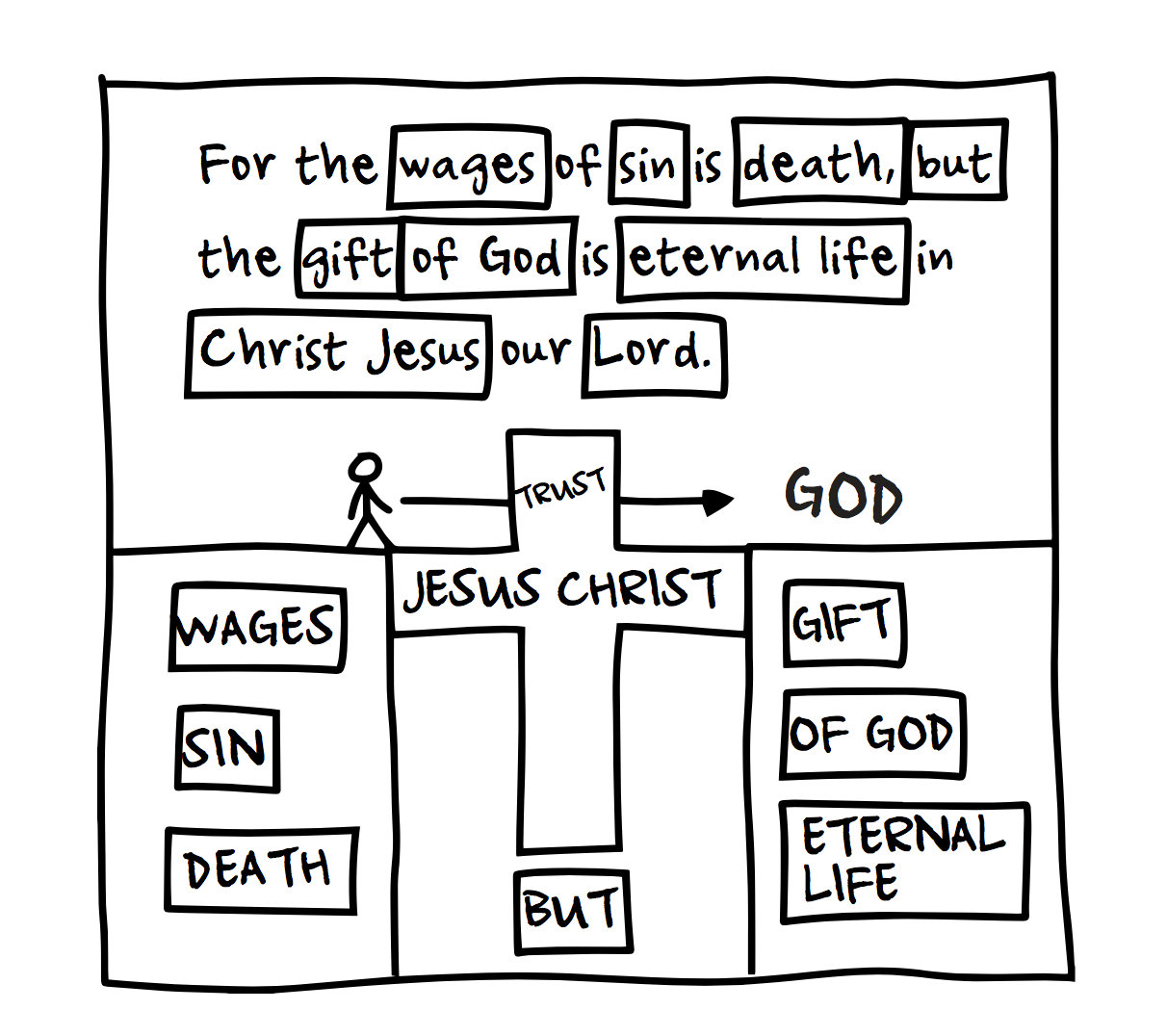
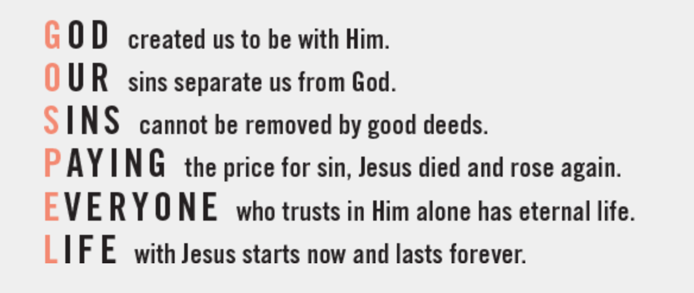

Challenge: Encourage students to continue using “The Other Six” to connect with God, and also to share their faith in Jesus with someone this week. Challenge them to invite someone to youth group next week.

Stay Connected: Text each student individually later in the week to check in and encourage them! Also, post the follow-up social media graphic and devo for the week so your students see it!

