WHAT THE BIBLE HAS TO SAY ABOUT IT

Notes:
_____________________________________________________________________________________________________
_____________________________________________________________________________________________________
_____________________________________________________________________________________________________
_____________________________________________________________________________________________________
_____________________________________________________________________________________________________
_____________________________________________________________________________________________________

THE BIBLE IN YOUR LIFE
Read Exodus 3:1–15 and 4:1–17, then answer the following questions.

Answer:
How did God handle Moses’ objections (both his honesty and his disobedience)?

Have you ever asked God any heartfelt questions? What happened?

What’s encouraging about the truth that you can be real with God?

In what areas of your life is it hardest to be honest with God?
APPLY IT  In the previous discussion, you just identified areas of your life where it’s hard to be honest with God. Pick one area to focus on this week. How can you draw near to God by being completely honest with him? | Be specific:  What are you going to do?  When are you going to do it?  Is there someone who can keep you accountable?

PRAYER
Take time to pray for each other’s application steps in the upcoming weeks.

THE TAKEAWAY
Honesty in relationships is important. We can be real with God—he can handle it.

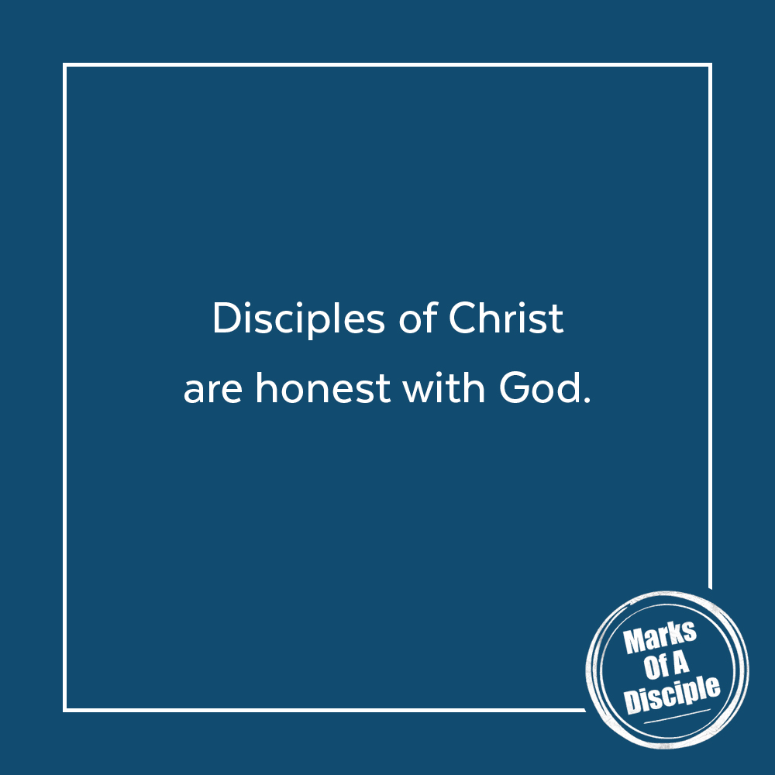
MEMORY VERSE
“I cry aloud to God, aloud to God, and he will hear me.”
Psalm 77:1 (ESV)
A QUOTE TO THINK ABOUT
“If we can’t bring our real selves to the real God, who else can we turn to? He will hold us and be near.”
– Rend Collective

