WHAT THE BIBLE HAS TO SAY ABOUT IT

Notes:
_____________________________________________________________________________________________________
_____________________________________________________________________________________________________
_____________________________________________________________________________________________________
_____________________________________________________________________________________________________
_____________________________________________________________________________________________________
_____________________________________________________________________________________________________

THE BIBLE IN YOUR LIFE
Read 1 Samuel 3, then answer the following questions.

Answer:
What did Eli tell Samuel to say to God? Why is that important?

How can you know if a message is truly from God?

What are some more unusual or rare ways God can speak to people?

What are some ways you can show God that you’re ready to listen to him?
APPLY IT  The main way God communicates with us today is through his Word. Have you taken time to listen to what God has to say to you by reading your Bible? Spend some time reading 1 John 4 this week as you learn how you might listen to God. | Be specific:  What are you going to do?  When are you going to do it?  Is there someone who can keep you accountable?

PRAYER
Take time to pray for each other’s application steps in the upcoming weeks.

THE TAKEAWAY
God communicates with us, and it's our job to listen and respond.

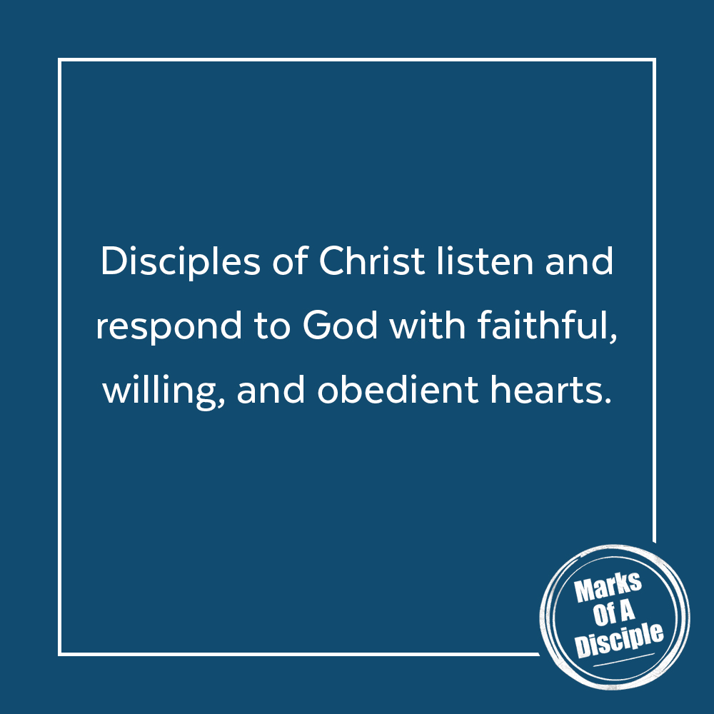
MEMORY VERSE
“Call to me and I will answer you, and will tell you great and hidden things that you have not known.”
Jeremiah 33:3 (ESV)
A QUOTE TO THINK ABOUT
“The willingness to obey every word from God is critical to hearing God speak.” – Henry T. Blackaby

