OVERVIEW
This lesson addresses one of the most important issues in Christian life: sin after salvation. How does salvation affect our ability and desire to sin? Why do we go on sinning if we are alive with Christ? Too often we take a trivial approach to sin—after all, Christ forgives! What’s the big deal if we still sin a little? Students will learn about the nature of grace and why following Jesus is so much more than just “stop sinning.” Students will be challenged to take an honest look at the sin in their lives and consider their new nature of being slaves to Christ instead of slaves to sin.
TEACHING

OPENING QUESTION
- How would you define sin?

WHAT THE BIBLE HAS TO SAY ABOUT IT
“If Jesus died for our sins and we’re saved by grace, then why is sin such a big deal? Can’t I go on living how I want and still make it into heaven?” Most Christians (maybe even you!) have probably asked these questions at some point—even if they don’t say it out loud. But this is a sharp misunderstanding of the Gospel and of the life God wants for us. It would be a convenient system to get all the perks of salvation through Jesus, but none of the responsibilities. However, obeying God isn’t just about getting into heaven or trying to stop sinning. We pursue a relationship with God because it transforms us into who he made us to be: holy, like Christ himself.
Read Romans 6:1–23.
True life comes from obedience to Christ. Obedience doesn’t sound like a life of freedom at first glance. But those who don’t belong to Christ are living shackled lives—they are bound to their sinful nature, unable to please God (Rom. 8:8; Heb. 11:6). They don’t experience God’s grace when they sin, and their actions result in death (v. 23). On the other hand, when we become God’s children, we’re given a new life in Christ—one that is free to choose to obey him! Out of love for him, we get to serve and obey Christ, which leads to holiness and eternal life (v. 22).
As God’s children, we live under grace. It’s true that the grace of God is limitless. When we confess our sins, he does forgive and cleanse us (1 John 1:9). But if we have a real relationship with Jesus, our obedience isn’t a chore. Life in Christ is much more than a simple transaction of “I’ll give you obedience if you give me eternal life.” We follow the example of Jesus and live under his authority out of response to his sacrifice. When we develop an authentic relationship with him, it becomes a desire in our hearts to be more like him.
Facilitator’s Note: There’s a lot of talk about ‘slavery’ in this passage from Romans. Given the overtly negative connotations of this term, prepare to answer questions from your students about what Paul means. The Bible never condones slavery, since we are all made in the image of God (Gen. 1). But Paul uses it as a picture of devotion and service to our Lord—not as a duty, but as a loving response to his love for us (1 John 4:19). You may find this article on the Ravi Zacharias International Ministries website helpful in your personal study of this difficult topic.¹

A SECOND LOOK
Pick one of these illustrations to bring the topic to life.

Option 1: Recipe for Success
Cake is delicious. In fact, I’d like to bake one. I know that it at least requires eggs, flour, sugar, and milk, but I don’t know how much of each. I’m sure it will be fine if I just toss a bunch of each into a bowl, mix it together, and then bake it for…four hours? At 500 degrees? This cake will be fantastic! Who needs a recipe?

Sometimes we try to live out our faith in the same way I’m trying to bake this cake. I want the wonderful, tasty end result, but I don’t want to follow the recipe for how to get there. God’s gift of eternal life is freely given, but if we’re just living for the end result (eternal life in heaven), then we’re missing out on what he has intended for us in this life. There’s a recipe to follow. When we obey his instructions, the end result is so much better.

Discuss:
- How is following and obeying Jesus kind of like following a recipe?
- Why does God want us to spend our lives becoming like Christ instead of magically making us perfect right away?
- In what areas of your life are you struggling to obey God right now?

Option 2: The Finale
Not too long ago, the ninth and final Star Wars movie in the Skywalker saga was released, concluding a film series spanning 42 years! For many people, this was a long-awaited film, the culmination of a long, long journey. But for some movie goers, this was their first time to see a Star Wars movie. Those new viewers could not fully understand or appreciate the story like those long-suffering fans who followed every release for the last four decades. Trying to skip ahead to the final movie is a bit like trying to skip ahead to heaven (perfection, being in God’s presence, etc.) while ignoring all the work that leads up to it. It’s understandable to want to skip the hard work of becoming like Christ. But if you’re not around for the whole story, waiting patiently, growing, watching, obeying, and praying, then the finale won’t mean much to you.

Discuss:
- In what ways does God show you grace in your day-to-day life?
- What are some aspects of your spiritual life now that you especially need God’s help in?
- What are you most looking forward to in heaven, the finale?

THE TAKEAWAY
Christ has saved us from our slavery to sin. If we think we can continue to sin
because God has grace, we don’t really understand grace.

DISCOVER
- The amazing truth of God’s grace is that we are made clean when God forgives us. When have you struggled to accept God’s grace in being forgiven?

THE BIBLE IN YOUR LIFE
God’s grace is vast and wide. It’s so big, in fact, we might think, “If God will forgive me, why do I need to worry about being free from sin?” Following Jesus isn’t just about escaping hell and gaining eternal life. It’s about becoming who he created us to be—holy and righteous children of God. The life of a Christ-follower comes to find obedience to God’s Word as a desire of the heart, not a chore.
APPLICATION
Read Romans 6:1–23, then answer the following questions.
Discuss:
- What is the outcome of being a slave to sin versus being a slave to righteousness?
- Is it possible to both follow Jesus and still actively sin? Why or why not?
- Do you have sin in your life you haven’t given over to God yet? What are you going to do about it?
- How does knowing that God rescued you from a life of slavery to sin help you in your obedience?

APPLY IT
In John 8, Jesus tells a woman “go and sin no more.” This wasn’t a suggestion—it was a command. Jesus gives us the same command when we find new life in him: sin no more. Identify a sin that you struggle with and make a specific plan for what to do each time you are tempted to sin in that area. This might include texting a friend and asking for prayer, reading a Psalm, reciting a helpful Bible verse, or praying through it.
Be specific:
- What are you going to do?
- When are you going to do it?
- Is there someone who can keep you accountable?

PRAYER
Take time to let your students pray for each other’s applications in the upcoming weeks.

A QUOTE TO THINK ABOUT
“For grace is given not because we have done good works, but in order that we may be able to do them.” – St. Augustine

THE TAKEAWAY
Christ has saved us from our slavery to sin. If we think we can continue to sin
because God has grace, we don’t really understand grace.

Here are some tools that you can use to follow up with your students throughout the week. For example, send any of the graphics included in your download to your students later this week to keep the conversation going.
WAYS TO FOLLOW UP

MEMORY VERSE  “What shall we say then? Are we to continue in sin that grace may abound? By no means! How can we who died to sin still live in it?”  Romans 6:1–2 (ESV) |  | 
MARK OF A DISCIPLE  Marks of a Disciple are a great way to figure out whether your students are growing in their understanding of God’s story and how to connect it to their daily lives. As Scripture impacts your students’ hearts, they’ll begin to live differently, and these Marks of a Disciple are a great guidepost to help them grow more Christ-like. Periodically check in with your students about one or two of these Marks of a Disciple that seem to be speaking to them specifically in this season. |  | 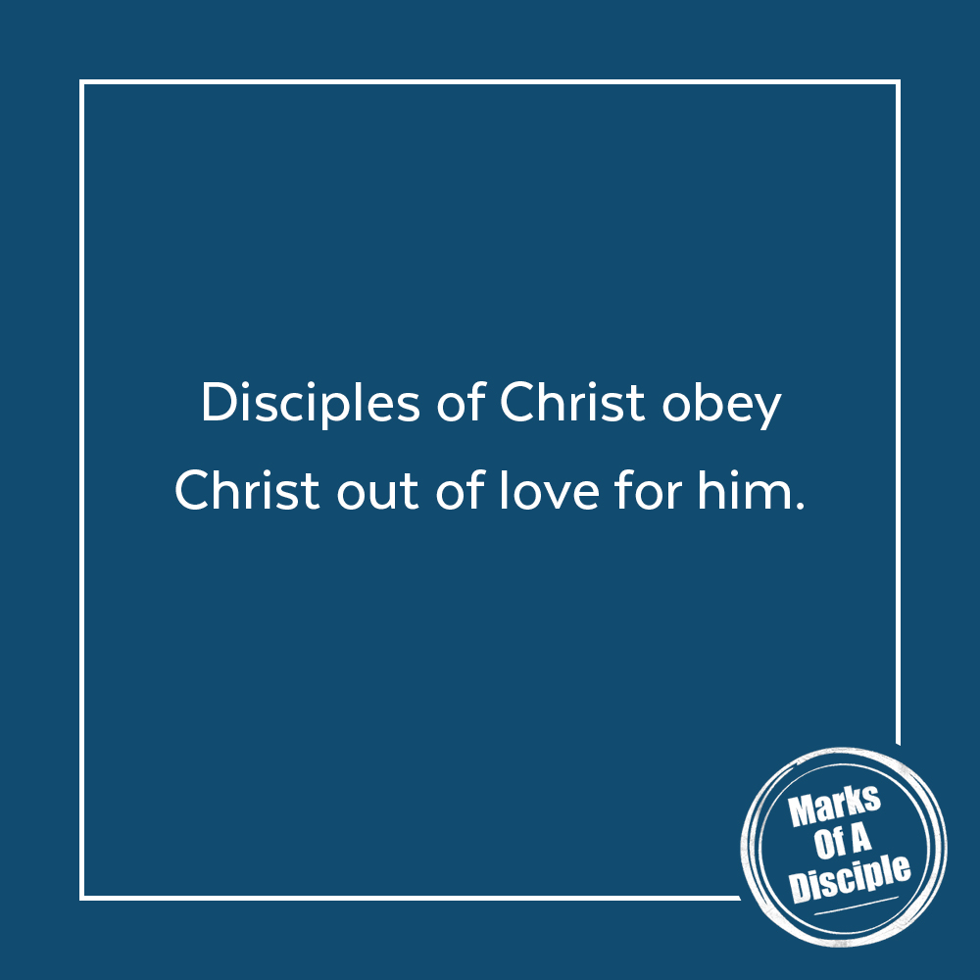

Scripture quotations are from the ESV® Bible (The Holy Bible, English Standard Version®), copyright ©2001 by Crossway, a publishing ministry of Good News Publishers. Used by permission. All rights reserved. May not copy or download more than 500 consecutive verses of the ESV Bible or more than one half of any book of the ESV Bible.
Any reference within this piece to Internet addresses of websites not under the​ ​administration of LeaderTreks is not to be taken as an endorsement of these​ ​websites by LeaderTreks;​ ​neither does LeaderTreks vouch for their content.

¹ Brandon Cleaver, “How Can I Trust the Bible When It Was Used to Justify Slavery?” RZIM, accessed May 1, 2020, https://www.rzim.org/read/rzim-global/how-can-i-trust-the-bible-when-it-was-used-to-justify-slavery. St. Augustine, A Treatise on the Spirit and the Letter (Savage, MN: Lighthouse Publishing, 2018).

