WHAT THE BIBLE HAS TO SAY ABOUT IT

Notes:
_____________________________________________________________________________________________________
_____________________________________________________________________________________________________
_____________________________________________________________________________________________________
_____________________________________________________________________________________________________
_____________________________________________________________________________________________________
_____________________________________________________________________________________________________

THE BIBLE IN YOUR LIFE
Read Matthew 4:18–22 and Matthew 19:16–30, then answer the following questions.

Answer:
Why do you think it was harder for the rich young man to give up his possessions than it was for the disciples?

What does “many who are first will be last, and the last first” mean?

Is it better to have treasure on earth or in heaven? Why?

Consider your own walk with Jesus. In what parts of your life do you struggle to obey, commit, and sacrifice for Christ?
APPLY IT  What things do you have in your life that might be standing in the way of you completely following Jesus? Take some time to identify the idols in your life and decide on a few steps on how to put Jesus first again. | Be specific:  What are you going to do?  When are you going to do it?  Is there someone who can keep you accountable?

PRAYER
Take time to pray for each other’s application steps in the upcoming weeks.

THE TAKEAWAY
Truly following Jesus requires committing to the relationship,
obeying what he says, and sacrificing anything that gets in the way.

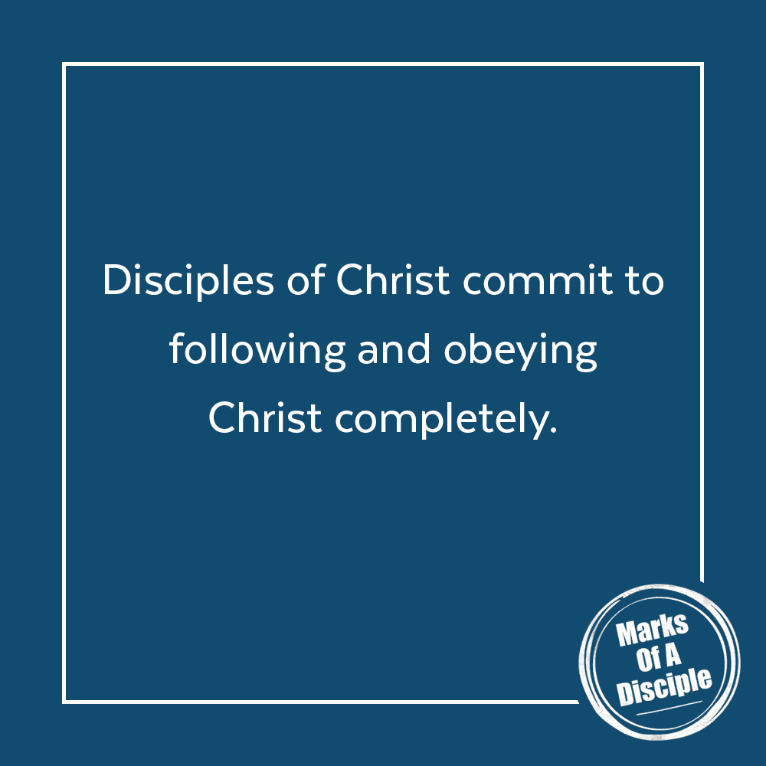
MEMORY VERSE
“For what will it profit a man if he gains the whole world and forfeits his soul? Or what shall a man give in return for his soul?”
Matthew 16:26 (ESV)
A QUOTE TO THINK ABOUT
“What good would it be if you had everything,
But what you didn’t have was the only thing you need?”
– Mark Stuart/Audio Adrenaline

