WHAT THE BIBLE HAS TO SAY ABOUT IT

Notes:
_____________________________________________________________________________________________________
_____________________________________________________________________________________________________
_____________________________________________________________________________________________________
_____________________________________________________________________________________________________
_____________________________________________________________________________________________________
_____________________________________________________________________________________________________

THE BIBLE IN YOUR LIFE
Read James 4:1–10, then answer the following questions.

Answer:
What does it look like to draw near to God?

What are some things that might keep you from having a close relationship with God? Look for specific examples in the passage.

What are some things that might keep you from having a strong relationship with the people around you?
APPLY IT  Decide on two ways you can work together with your friends to have a stronger relationship with God this week. | Be specific:  What are you going to do?  When are you going to do it?  Is there someone who can keep you accountable?

PRAYER
Take time to pray for each other’s application steps in the upcoming weeks.

THE TAKEAWAY
God promises to draw near to us as we draw near to him and his people.

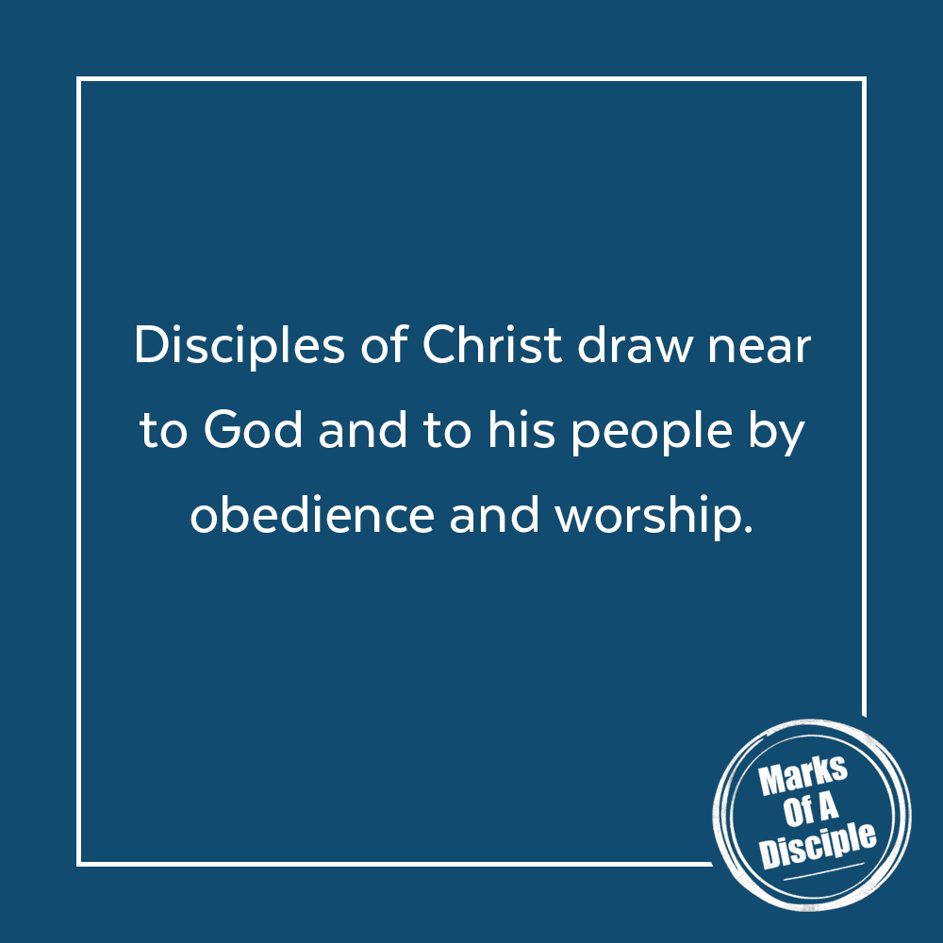
MEMORY VERSE
“Draw near to God, and he will draw near to you.”
James 4:8 (ESV)
A QUOTE TO THINK ABOUT
“The Christian life from start to finish is based upon this principle of utter dependence upon the Lord Jesus.”
– Watchman Nee

