OVERVIEW
One of the trickiest parts of doubt is when it makes us wonder “Is following God even worth it?” We might doubt that God’s promises will be fulfilled, or maybe we doubt that the spiritual blessings we have in Christ are really more valuable than what we could get from the world. Students will be reminded of how faithful God is and that following God is truly worth it by exploring the immeasurable value of God’s good gifts to his children—forgiveness, fulfillment, life, and purpose, just to name a few.
TEACHING

OPENING QUESTION
- When have you given or received a valuable gift (not necessarily monetarily), and how did you feel toward that person after giving or receiving the gift?

WHAT THE BIBLE HAS TO SAY ABOUT IT
There may be times in your life when doubt weighs heavy and you ask, “Is following God even worth it?” We see others rebelling yet prospering, and we wonder if maybe they have it easier. In those seasons, it’s important to turn to Scripture and be reminded why following God is worth it.

Read Psalm 73:1–3, 12–13 and Ephesians 1:3–14.

You’re not alone. If you’ve ever grown frustrated with obedience and questioned whether a commitment to following God was worth it, you’re not alone! The author of Psalm 73 looked on the wealth and prosperity of wicked people, and he envied them. When this happens, though, we should cry out to God, just as we see in this Psalm, and we will be reminded of his goodness.

God is always faithful. We may be temporarily impressed by all the things people who don’t follow Jesus seem to have, but in Ephesians, we’re reminded of what holds true value: God’s faithfulness. This is a gift he’s been planning for us since the beginning of time, and it will last throughout eternity. He has been faithful to us, which is worth so much more than monetary wealth or earthly power.

Look at all the benefits of following God. As children of God, we have “every spiritual blessing in the heavenly places” (Eph. 1:3). God, in his glorious grace, chose us to be holy and blameless. We have redemption and forgiveness, the riches of his grace, the knowledge of God’s will (which is “to unite all things in him” (Eph. 1:10), the promise of an inheritance, and the Holy Spirit as a “guarantee of our inheritance until we require possession of it” (Eph. 1:14). We truly lack nothing! And the best part is that God is the one who does it all. We’re simply grateful recipients of his good and generous gifts.
Facilitator’s Note: It’s tough for teenagers to really understand the value (or lack thereof) of worldly pleasures. Eternity is an abstract and far off concept when compared to the immediacy of things in front of them right now. Your students might not get this lesson by the end of your time together; they might still often wonder if following Jesus is really worth it. However, the seeds you plant now may bear fruit as they grow older and gain better perspectives on value.
A SECOND LOOK
Pick one of these illustrations to bring the topic to life.

Option 1: Eternal Treasury
Looking around at some of your classmates, you might see their seemingly perfect lives—especially on social media. Their parties are well-attended, they wear designer clothes, their parents let them do anything they want, and they have a 4.0 GPA on top of all that. They brag about how great their spring break vacation was, how much they paid for their new car, and how great their girlfriend or boyfriend is. Now, there’s nothing wrong with wearing designer clothes and getting good grades. But remember, if a person is not a child of God, their heart and life are far from benefiting from God’s goodness, faithfulness, and generosity. They may have wealth and success here on earth, but their eternal treasury is empty and hopeless. Sadly, they don’t care about the spiritual wealth that God offers them.

Discuss:
- What kinds of earthly wealth or success do you notice in your peers?
- Why do you think God wants us to focus on the spiritual benefits of following him?
- How do you feel knowing that what is on earth will not last in eternity?
Option 2: Eternal Life is Better
When a powerful tornado tears through a neighborhood, it rips up houses by their roots and turns them upside down. You’ve likely seen pictures and videos of the aftermath from a powerful storm. Amidst these unthinkable tragedies, survivors often look around at the rubble, then go and hug their family members tight. Though the recovery will be hard, they’ve come to realize what truly matters. Our things can be replaced, but lives cannot. You can build a mansion and fill it with all your things, but a fire or a tornado or a terrible flood could come through and, in an instant, take it all away. Physical stuff is temporary. Life, though, is precious and eternal. Christ came to offer you a gift that can’t be taken away—the gift of eternal life.

Discuss:
- Why is a human life more valuable than any amount of earthly possessions?
- How do Jesus’ gifts to us compare to all of the stuff you own?
- What things are you tempted to value more than Jesus?

THE TAKEAWAY
Although it can be hard, following Jesus is worth it.

DISCOVER
- When is it most tempting for you to question whether following Jesus is worth it?
APPLICATION

THE BIBLE IN YOUR LIFE
When you look around and see people claiming satisfaction in worldly pleasures, you might wonder if following Christ is really worth it, as the Psalmist does. But as Paul reminds us in Ephesians, the spiritual gifts of God far outweigh anything this world can offer.

Read Psalm 73:1–3, 12–13 and Ephesians 1:3–14, then answer the following questions.

Discuss:
- When have you felt jealous of non-believers?
- What do we as believers have that others don’t?
- What is the proper response to receiving all these spiritual blessings from the Lord? (Hint: look at Ephesians 1:6, 12, and 14.)
- When you doubt the value of following God, what can you do?

APPLY IT
When we’re tempted to believe that following Jesus isn’t worth it, it’s helpful to remember who he is and all that he’s given us. How can you remind yourself of God’s good gifts and faithfulness this week?

Be specific:
- What are you going to do?
- When are you going to do it?
- Is there someone who can keep you accountable?

PRAYER
Take time to let your students pray for each other’s applications in the upcoming weeks.

A QUOTE TO THINK ABOUT
“Following Christ isn't something that can be done halfheartedly or on the side. It is not a label we can display when it is useful. It must be central to everything we do and are.” – Francis Chan

THE TAKEAWAY
Although it can be hard, following Jesus is worth it.

Here are some tools that you can use to follow up with your students throughout the week. For example, send any of the graphics included in your download to your students later this week to keep the conversation going.
WAYS TO FOLLOW UP

MEMORY VERSE
“Blessed be the God and Father of our Lord Jesus Christ, who has blessed us in Christ with every spiritual blessing in the heavenly places…”
Ephesians 1:3 (ESV)
MARK OF A DISCIPLE  Marks of a Disciple are a great way to figure out whether your students are growing in their understanding of God’s story and how to connect it to their daily lives. As Scripture impacts your students’ hearts, they’ll begin to live differently, and these Marks of a Disciple are a great guidepost to help them grow more Christ-like. Periodically check in with your students about one or two of these Marks of a Disciple that seem to be speaking to them specifically in this season. |  | 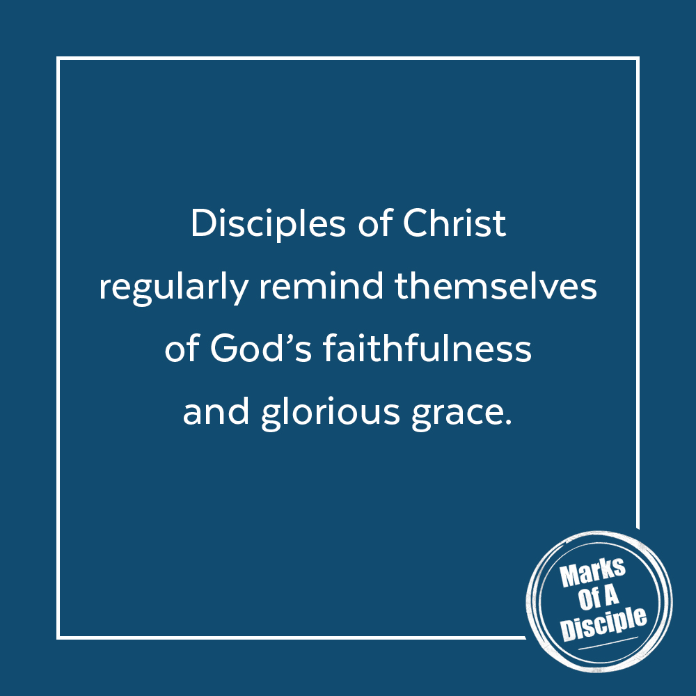

Scripture quotations are from the ESV® Bible (The Holy Bible, English Standard Version®), copyright ©2001 by Crossway, a publishing ministry of Good News Publishers. Used by permission. All rights reserved. May not copy or download more than 500 consecutive verses of the ESV Bible or more than one half of any book of the ESV Bible.
Any reference within this piece to Internet addresses of websites not under the​ ​administration of LeaderTreks is not to be taken as an endorsement of these​ ​websites by LeaderTreks;​ ​neither does LeaderTreks vouch for their content.

Francis Chan, Crazy Love (Colorado Springs: David C. Cook, 2008), 94.

