OVERVIEW
An important part of developing a mature and authentic faith is dealing with feelings of doubt. Doubt is impossible to avoid—it’s the natural result of our God-given brains. How do I know God is real? Why should I believe that Jesus rose from the dead? Learning to deal well with questions like these is something every Christian has to be prepared to work through. In this lesson, students will look at examples of people in the Bible who experienced doubt and discuss how those people handled their struggles. They’ll learn that in times of doubt, the best thing we can do is turn to God and seek his help.
TEACHING

OPENING QUESTION
- What do you think doubt looks or feels like?

This could be a fun question…or it could be one which does not have any responses at all. If you need a few funny questions to lead into it, you could say, “What do you think doubt looks or feels like?” And when they don’t respond, say, “Okay, what do you think a duck looks or feels like?” What do you think an elephant looks or feels like? What do you think a roller skating accident where you crash into a wall looks or feels like? What do you think a phone call where you tell your mom or dad you put water in the gas tank of their car – because you borrowed their car and drove too far and figured you could just water down the gas and they wouldn’t notice you used so much gas – looks or feels like?

Another intro you could use – which goes off of the “He said She said God said” idea: Have a can/bottle of coke and one of dr. pepper. Have someone who likes coke better than dr pepper…and someone who likes dr pepper better than coke… come up and give a 20 second persuasive talk about why their choice is better.

Use this to talk about how just because someone says something, doesn’t mean it’s true. Example, someone could say Taco Bell is a good restaurant. That doesn’t mean it’s true. But what happens when someone says “God is real” and someone else says “God is not real”…what do we do then? There will always be people who acknowledge the truth of God and there will always be people who are against God or do not believe He is real. Just because someone says something does not make it real. (again, taco bell, ha.)

You can go farther with the He said She said God said idea, so feel free to take it farther if you want to.

WHAT THE BIBLE HAS TO SAY ABOUT IT
Everything had been perfect up until now. Creation was pristine, unblemished by sin. Adam and Eve lived in perfect harmony with their Creator. But the serpent was “more crafty” than any of the other wild animals, and with his forked tongue, he whispered into Eve’s ear. For the first time in history, the questions arose: Do I actually have to do what God said? Why should I listen to him?
Doubt was always inevitable. When God endowed Adam and Eve with his image and gave them the ability to reason, he also gave them the opportunity to choose: obedience or disobedience. The serpent whispered into this vulnerability, and doubt was born.
Facilitator’s Note: Historically, doubt in the Christian church has often been met with shame, anger, and a cold response. Encourage your students as they wrestle with tough questions and be a calm, comforting presence. You don’t have to have all the answers—just be someone they trust to be honest with them. You should also encourage them to not become comfortable in their doubt. The goal should be to get answers from the Bible, repent of the lack of trust in God (that’s what doubt really is!), and pray for their faith to be strengthened through their questions. The article “Does Your Doubt Dishonor God?” by Greg Morse¹ might be helpful in thinking through faith vs. doubt in a biblical manner.

Read Genesis 3:1–7 and Jeremiah 1:1–9.
(you can use these next notes – and anything else you want - to give students something to write down in the notes section of their handout.)
One suggestion (either before or after the notes – if you choose to give them anything to write down): after you read through a specific text, maybe pick 2-3 things to ask them about. For example, in Jeremiah 1:1-9, you could ask: what is something God says to Jeremiah in what we just read? Using some simple, reading comprehension-type, questions is a decent way to get some discussion going – and it’s always good if they will talk instead of having to just listen to us the whole time.
I like using questions like this right after we read through something, to hopefully help them be ready for the discussion questions listed in this lesson.
Doubt is natural. These two accounts show people who were very close to God. Eve walked side-by-side with God in the Garden, and Jeremiah was one of God’s chosen prophets—he spoke God’s words. Yet both people experienced doubt. It doesn’t matter how close you get to God. Doubt is a natural part of life for people who have brains.
What not to do with doubt. When the serpent twisted God’s words and led Eve into confusion, she could have turned to God for answers. Instead, she leaned into doubt and committed the first sin. Eve tried to make decisions in her own faulty reasoning, forgetting that God’s wisdom is unsearchable and perfect.
Now read Mark 9:24.
What to do with doubt. When Jeremiah doubted his ability to do God’s will, he asked for assurance. He knew that he couldn’t do God’s will in his own strength, but he trusted God’s words and abilities to work through him. In Mark, we see a father exclaim “help my unbelief!” When we feel doubt creeping in, we should do as Jeremiah and the father did—go directly to God for help. Be honest with him about your doubt and ask him to strengthen your faith.

A SECOND LOOK
Pick one of these illustrations to bring the topic to life.

Option 1: Center of the Universe
Galileo is famous for arguing that the Earth revolved around the sun, a belief that directly contradicted the commonly held belief that the Earth was the center of the solar system and everything revolved around us. Perhaps most upset by this argument was the Catholic Church who felt that Galileo’s claim challenged the authority of Scripture and was an offense to God. The Church feared that if scientific discovery claimed one thing and their interpretation of Scripture claimed another, people might start to doubt the validity of God’s Word. In response to these fears of doubt, the Church condemned Galileo as a heretic and sentenced him to indefinite imprisonment. Talk about an unhealthy response to doubt!

Discuss:
- Why do you think the Catholic Church was so harsh with Galileo and angry about his beliefs?
- How is doubting a church’s teaching different than doubting God’s Word?
- If you or someone you know have doubts about a teaching of the church, what’s the best thing to do about it?
Option 2: Check the Records
Did you know that Donald Gorske holds the record for Most Big Macs ever eaten? He’s had over 26,000! And did you know that on July 23, 2013, 867 people showed up to a music festival dressed as Superman? They set the world record for Largest Gathering of People Dressed as Superman. Don’t believe it? All you have to do is turn to the Guinness Book of World Records, where all sorts of crazy, unthinkable records are kept. If you doubt the truth of a claim, just check out the record books. The same is true for us as Christians. When you experience doubt, check out God’s Word! What has he promised? And how has he fulfilled those promises? You’ll see time and time again that our God is faithful.

Discuss:
- God has done some pretty incredible things. What are some of the (almost) unbelievable stories of the Bible?
- Do accounts of miracles in the Bible encourage your doubt or strengthen your faith? In what ways?
- What are some of the promises in the Bible that show God’s faithfulness?

APPLICATION

DISCOVER
- When have you experienced doubt in regards to your faith, the Bible, or Jesus?

THE BIBLE IN YOUR LIFE
Doubt is not just a modern problem. The Bible has plenty of examples of people who experienced doubt long before any of us were born. It doesn’t matter how close you are to God; everyone will doubt to some extent at some point! Eve was the first doubter, but certainly not the last. In these passages, we see a bad way to handle doubt and some good ways.

Read Genesis 3:1–7, Jeremiah 1:1–9, and Mark 9:24, then answer the following questions.

Discuss:
- Where do you think doubt comes from?
- Is doubt a sin? Why or why not? (Passages to help you answer: Romans 4:20–21; James 1:5–8)
- Why is it unhealthy to dwell in doubt for long periods of time?
- On a scale of 1–4 (4=the quickest), how quickly do you turn to God for answers when you doubt?

APPLY IT
You’re going to have feelings of doubt. If you haven’t already, there will come a time in your life when you will ask “Is this all real? Is God really with me? Did Jesus really die for my sins?” When that time comes, how are you going to handle it?

Be specific:
- What are you going to do?
- When are you going to do it?
- Is there someone who can keep you accountable?

PRAYER
Take time to let your students pray for each other’s applications in the upcoming weeks.

A QUOTE TO THINK ABOUT
“If you would be a real seeker after truth, it is necessary that at least once in your life you doubt, as far as possible, all things.” – René Descartes

THE TAKEAWAY
When we doubt, the proper response is to go directly to God and ask him for help.

Here are some tools that you can use to follow up with your students throughout the week. For example, send any of the graphics included in your download to your students later this week to keep the conversation going.
WAYS TO FOLLOW UP

MEMORY VERSE  “I believe; help my unbelief!”  Mark 9:24 (ESV) |  | 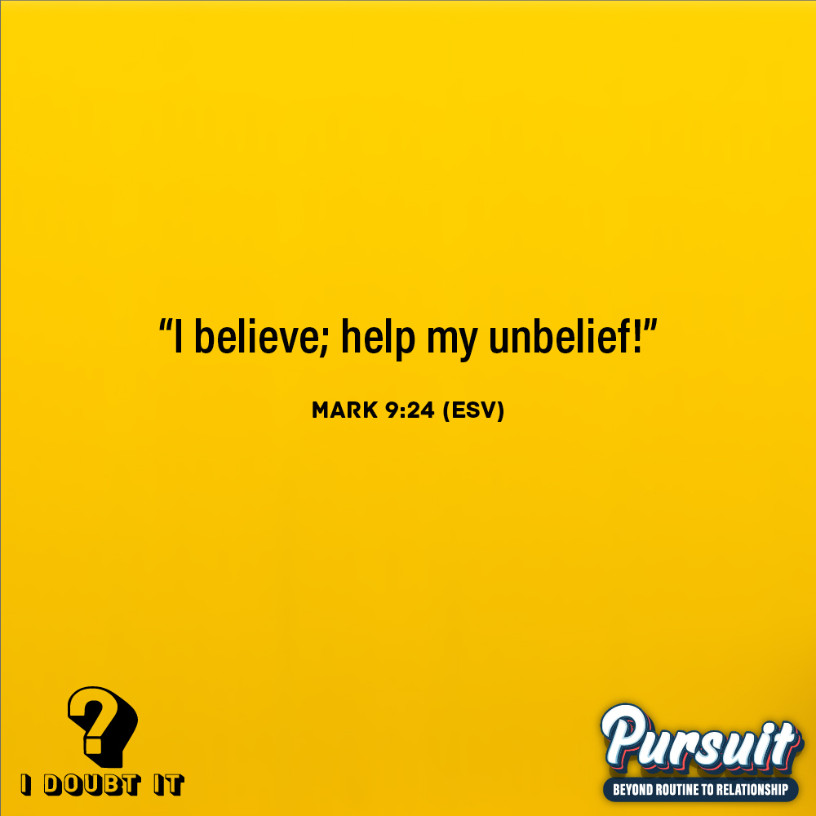
MARK OF A DISCIPLE  Marks of a Disciple are a great way to figure out whether your students are growing in their understanding of God’s story and how to connect it to their daily lives. As Scripture impacts your students’ hearts, they’ll begin to live differently, and these Marks of a Disciple are a great guidepost to help them grow more Christ-like. Periodically check in with your students about one or two of these Marks of a Disciple that seem to be speaking to them specifically in this season. |  | 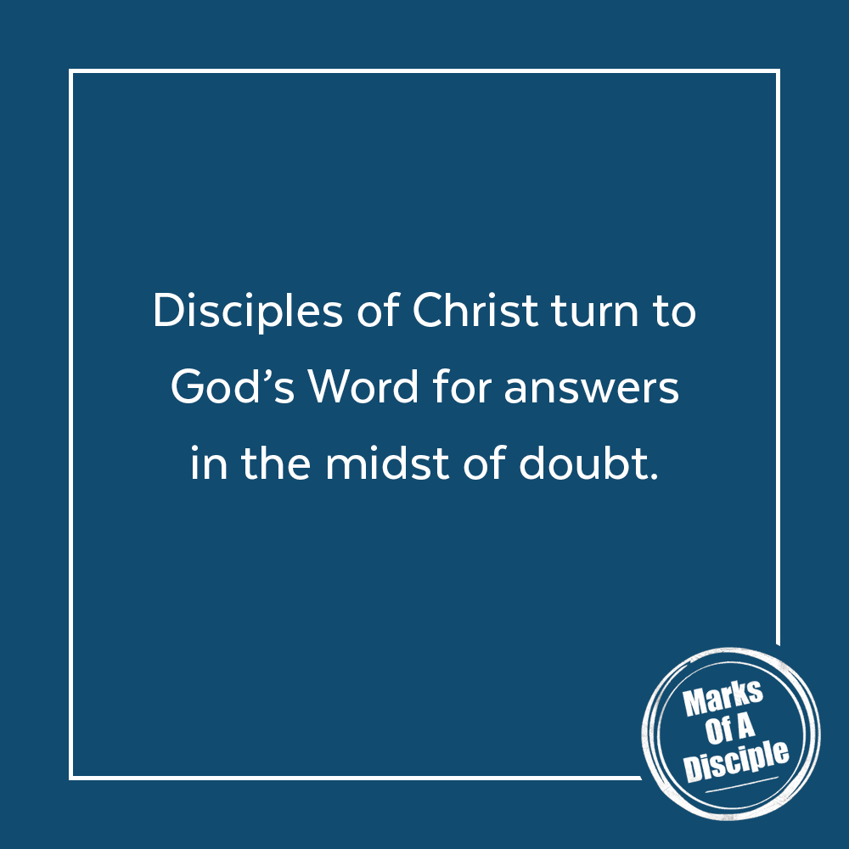

Scripture quotations are from the ESV® Bible (The Holy Bible, English Standard Version®), copyright ©2001 by Crossway, a publishing ministry of Good News Publishers. Used by permission. All rights reserved. May not copy or download more than 500 consecutive verses of the ESV Bible or more than one half of any book of the ESV Bible.
Any reference within this piece to Internet addresses of websites not under the​ ​administration of LeaderTreks is not to be taken as an endorsement of these​ ​websites by LeaderTreks;​ ​neither does LeaderTreks vouch for their content.

¹ Greg Morse, “Does Your Doubt Dishonor God? What No One Says About Weak Faith,” January 4, 2018, accessed May 1, 2020, https://www.desiringgod.org/articles/does-your-doubt-dishonor-god. “Galileo is convicted of heresy,” History.com, November 13, 2009, accessed May 1, 2020, https://www.history.com/this-day-in-history/galileo-is-convicted-of-heresy.
Most Big Mac® Burgers Eaten In A Life Time," Guinness World Records, accessed May 1, 2020, https://www.guinnessworldrecords.com/world-records/most-big-macs-consumed.
"Largest Gathering Of People Dressed As Superman," Guinness World Records, accessed May 1, 2020, https://www.guinnessworldrecords.com/world-records/largest-gathering-of-people-dressed-as-superman.
René Descartes, Principles of Philosophy, 1644.

