OVERVIEW
This Christmas lesson will place Jesus’ arrival in the context of the story of the Bible. While it’s commonly taught that prophets foretold the coming of Jesus, few churchgoers have a strong understanding of why God’s people had been looking forward to a Messiah. Isaiah 9 lands among a people who failed to keep their promise to be faithful to God, but it reminds them that God will pursue them faithfully—to the point of keeping their promise for them. Jesus pursues and saves his people because without him, they’re hopeless. Jesus perfectly fulfills Old Testament prophecy and will rule for eternity in righteousness and justice. Students will see how the anticipation of Jesus can be compared to the Harry Potter series and then contrast Jesus’ divine leadership with the amazing, yet limited leadership of some of the great humans of our age.
TEACHING

OPENING QUESTION
- When have you planned something far in advance? What was it for, and how did you plan?

WHAT THE BIBLE HAS TO SAY ABOUT IT
Israel had dropped the ball time and time again with God. They were unfaithful and didn’t want to follow God only, as their true King. They wanted earthly kings to rule them. God let his people try things their way, and several kings later, Israel found itself ruled by corrupt, evil men, and on the brink of defeat by foreign armies. Their plan hadn’t worked out, but God hadn’t given up on them. It’s here in Israel’s story that the prophet Isaiah wrote today’s passage.

Read Isaiah 9:1–7.

Isaiah prophesied the coming of Jesus. Even though no one had heard of Jesus yet, God had planned far, far in advance that Jesus—the great light—would come for his people who walk in the darkness. God spoke through Isaiah so that his people would know that a perfect Messiah was coming.

Jesus perfectly fulfills the prophecy. John’s gospel explicitly says that Jesus is the light (John 1). The light of Christ is visible to anyone walking in darkness. Jesus multiplies the nation of God’s people by bringing in all who put their hope in him. His rule is ever-expanding and never-ending, operating with justice and righteousness. There is no better King to follow than Jesus.

Jesus’ names show his nature. The well-known titles given to Jesus in this passage are names that describe his attributes, who he is by nature. Where human kings had led Israel in foolishness, Jesus leads as the Wonderful Counselor. He’s the Mighty God in place of the weakness of humans; he’s the Everlasting Father—constant where his people are fickle. He ushers in peace as the Prince of Peace when his people are not unified. Where generations of humans have failed to follow God perfectly, Jesus never fails to pursue us perfectly.

Facilitator’s Note: It might be a new concept to students that the Old and New Testaments are connected at all—not just a collection of morality parables. If this is the case with most of your group, please consider viewing this helpful video (see link in endnotes) which lays the context for why Israel was looking forward to the Messiah.¹
A SECOND LOOK
Pick one of these illustrations to bring the topic to life.

Option 1: Prophecy in Fiction
Even in fiction, the use of prophecy is common. Take the Harry Potter series, for example. Before Harry was born, it was prophesied that a boy would be capable of defeating Lord Voldemort. Throughout the books, it’s slowly revealed to the reader and to the characters in the story that Harry Potter was indeed the “Chosen One” to duel against the evil wizard. But there was a long period of waiting before that last duel happened. Once Harry realizes who he is, he willingly takes on the most powerful evil wizard, knowing he might die. In some ways, Harry is a Christ figure, willing to die for the safety of his friends and to defeat evil once and for all. In a similar way, the Israelites watched and waited for hundreds of years for God’s “Chosen One”—Jesus—to come and defeat death and sin and to free his friends from bondage so they can have eternal life. In both instances, there was a desperation and longing for someone to save them!

Discuss:
- If you’re familiar with the Harry Potter series, what other similarities or differences do you see between that story and the anticipation of the Messiah Jesus?
- How do you think the Israelites felt when they realized Jesus was their Messiah? (For one reaction, see Luke 2:25–38.)

Option 2: The Perfect Leader
History has seen incredible men and women rise up to lead their people to a better tomorrow. Abraham Lincoln, Martin Luther King Jr, Winston Churchill, Nelson Mandela, Harriet Tubman, and Malala Yousafzai are just a few people who have fought for human rights, equality, freedom, and peace. They were influential, but only to an extent. Each of these remarkable leaders give us a taste of what King Jesus has in store, but at the end of the day, they’re all human. Jesus is the eternal, perfectly righteous and just ruler whose Kingdom will never end. We long for and anticipate his wise, strong, everlasting, and peaceful rule, when all evil will end and when he will make all things new and right. Until then, we’re commanded to seek first God’s Kingdom and righteousness while here on earth and invite others into his Kingdom until he returns (Matt. 6:33; 28:16–20).

Discuss:
- Who is the best leader you can think of and why?
- What makes Jesus a better ruler than any other human?
- How has Jesus invited you to bring his Kingdom to the world around you?

THE TAKEAWAY
God’s plan of salvation was intentionally planned out and prophesied
thousands of years before Jesus came to Earth.

DISCOVER
- When have you waited in anticipation for something? How did you feel while waiting and then how did you feel when it finally happened?
APPLICATION

THE BIBLE IN YOUR LIFE
God planned from the beginning to save his people through Jesus Christ, the light of the world. Jesus completely fulfills the prophecies of the Old Testament, being the one to end all evil and rule perfectly forever as the Wonderful Counselor, Mighty God, Everlasting Father, and Prince of Peace.

Read Isaiah 9:1–7, then answer the following questions.

Discuss:
- How do you see God reaching out in love, grace, and forgiveness to his unfaithful people in this passage?
- What do prophecies like this show us about God?
- Where in your life do you feel like you’re walking in darkness?
- How has Jesus entered your world to shed light on your life?

APPLY IT
When we realize the bigger, eternal story of God’s pursuit of his people—and that he’s invited us to be in his family—we praise him for his love and faithfulness. Think of a specific way you can praise God for his loving pursuit of you this week.

Be specific:
- What are you going to do?
- When are you going to do it?
- Is there someone who can keep you accountable?

PRAYER
Take time to let your students pray for each other’s applications in the upcoming weeks.

A QUOTE TO THINK ABOUT
“The true Son left his home with the Father and went to the cross so that we who had run from the Father could be welcomed as sons.” – Trevor Laurence

THE TAKEAWAY
God’s plan of salvation was intentionally planned out and prophesied
thousands of years before Jesus came to Earth.

Here are some tools that you can use to follow up with your students throughout the week. For example, send any of the graphics included in your download to your students later this week to keep the conversation going.
WAYS TO FOLLOW UP

MEMORY VERSE
“For to us a child is born, to us a son is given; and the government shall be upon his shoulder, and his name shall be called Wonderful Counselor, Mighty God, Everlasting Father, Prince of Peace.”
Isaiah 9:6 (ESV)
MARK OF A DISCIPLE  Marks of a Disciple are a great way to figure out whether your students are growing in their understanding of God’s story and how to connect it to their daily lives. As Scripture impacts your students’ hearts, they’ll begin to live differently, and these Marks of a Disciple are a great guidepost to help them grow more Christ-like. Periodically check in with your students about one or two of these Marks of a Disciple that seem to be speaking to them specifically in this season. |  | 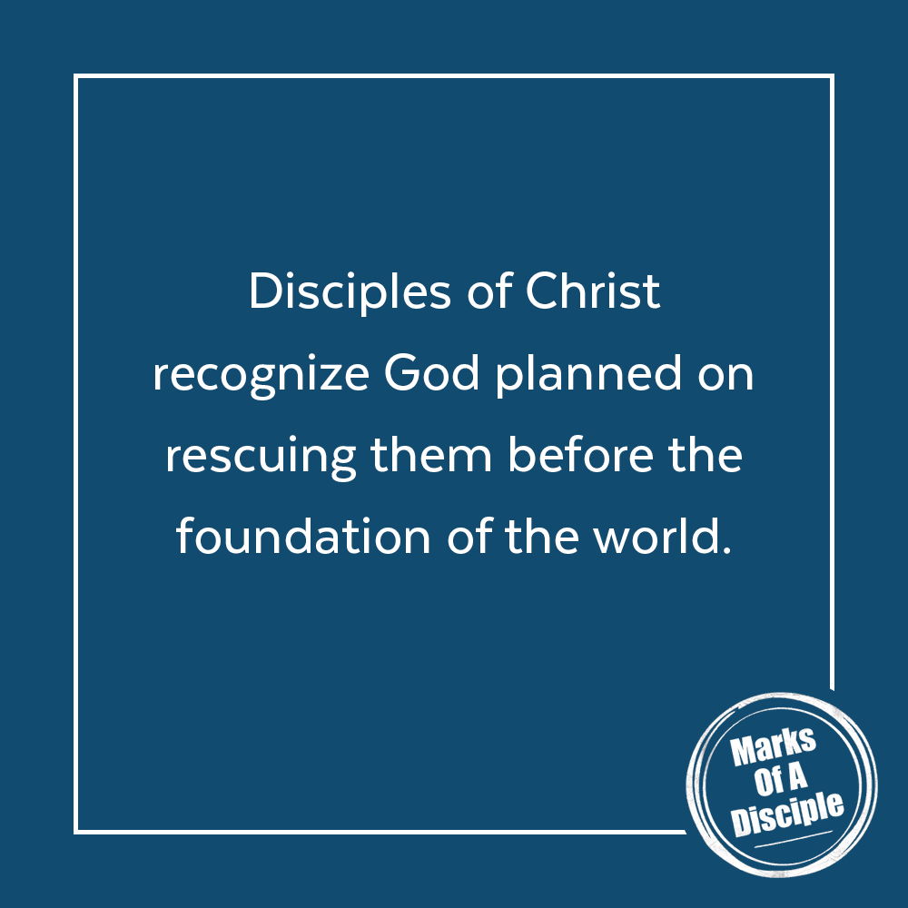

Scripture quotations are from the ESV® Bible (The Holy Bible, English Standard Version®), copyright ©2001 by Crossway, a publishing ministry of Good News Publishers. Used by permission. All rights reserved. May not copy or download more than 500 consecutive verses of the ESV Bible or more than one half of any book of the ESV Bible.
Any reference within this piece to Internet addresses of websites not under the​ ​administration of LeaderTreks is not to be taken as an endorsement of these​ ​websites by LeaderTreks;​ ​neither does LeaderTreks vouch for their content.

¹ BibleProject, “Messiah,” YouTube video, 5:47, [Posted September 30, 2014], https://www.youtube.com/watch?v=3dEh25pduQ8. “Sybill Trelawney’s first prophecy,” Harry Potter Wiki, Fandom, accessed May 1, 2020, https://harrypotter.fandom.com/wiki/Sybill_Trelawney%27s_first_prophecy.
Trevor Laurence, The Story of the Word: Meditations on the Narrative of Scripture (Eugene, OR: Wipf & Stock, 2017), 140.

