OVERVIEW
God wants us to want to be in a relationship with him and with others. In this lesson, your students will come to understand the importance of drawing near to God. As we draw near to God, he draws near to us. Not only does this work individually, but it also works when we seek God together. Second Looks remind us that community in the body of believers really is worth it and show the benefits of drawing near to each other in community, seeking God together.
TEACHING

OPENING QUESTION
- What’s something you’ve done alone that would have been easier or more enjoyable with friends?

WHAT THE BIBLE HAS TO SAY ABOUT IT
Have you ever tried to be friends with someone who just didn’t want to be friends with you? It takes two people to make a friendship. Both people have to want to be in it. That’s how it is with your relationship with God. You are made in his image, and he deeply desires a friendship with you, but he’ll never force his way in.

Read James 4:1–10.

Your main job is to show up. God wants you to want to be in a relationship with him. He’s not asking you to work for his favor; he just wants you to know and love him. James reminds us to humble and submit ourselves to God. And when we do, he promises to draw near to us.

Drawing near to God helps us live in unity. The people James was writing to were acting more like enemies than friends. Their fights were caused by their ungodly attitudes and behaviors. Instead, James urged them to seek God in humility. As we submit to and draw near to God, he transforms our hearts to be more Christ-like so we can live at peace with each other. Imagine if every believer was humble and submissive to God—fighting selfishness, resisting temptation, confessing sin—our relationships with others would be more unified, loving, and peaceful!

Drawing near to God works best in community. When you make a new friend, you start hanging out with their friend group. If you don’t make an effort to get to know the friend group—and vice versa—the new friendship might not last long. But if everyone welcomes and invests in each other, even stronger friendships are the result. The Bible tells us that we need others to help us follow God (see Prov. 27:17, Ecc. 4:9–12, Heb. 10:24–25). We are truly better together, encouraging and supporting each other as we collectively draw near to God.
Facilitator’s Note: To learn more about what it looks like to worship in community, read Acts 4:32. What does “one in heart and soul” mean? What would it look like if your group was “one in heart and soul”?

A SECOND LOOK
Pick one of these illustrations to bring the topic to life.

Option 1: Opening Night
It’s opening night of the biggest movie of the year. You’ve bought your ticket early; you’re wearing your themed gear. You can feel the excitement in the theater—everyone’s been looking forward to this as long as you have. It’s wonderful to experience a big event like this in community. Sure, sometimes it’s nice to go see a movie alone. You get to act and react exactly as you please without being concerned about anyone around you, but who is there to laugh at the same jokes as you? Who jumps at the same scares or is tender during that perfect story resolution? You want to be able to feel the energy and excitement in the room as everyone experiences the story together. In a similar way, worshiping and drawing near to God personally is a wonderful thing, but we also should practice doing this together. Sometimes it’s just better to experience things in community.

Discuss:
- What is your favorite group activity or experience?
- What might it look like to worship God together vs. worshiping God alone?
- Why is it important to worship God and grow in our Christian faith in community?

Option 2: Stone Soup
There’s an old folktale about a traveler who arrived in a village after a long journey. He was very hungry and tired but had nothing to eat. He hoped the villagers would share their food with him, but the villagers were selfish and refused. The traveler started to tell the villagers about his special stone that makes wonderful soup. This piqued the villagers’ interest! He said that all he needed for his soup was his stone, a pot, and some water—but he wouldn’t mind if the villagers wanted to contribute. Soon, the interested villagers had brought chicken, carrots, onion, mushrooms, and more. The villagers didn’t know it, but they were working together to make a wonderful soup that would feed everyone in their village, including the traveler. The traveler could’ve simply gone to a more generous village, but he decided to stick around and encourage them to come together. When a difficult situation arises in the body of Christ, sometimes the most beneficial thing is to stick around and encourage each other to seek God together.

Discuss:
- Why do you think the villagers didn’t want to help the traveler?
- Would the soup have been better if the villagers had volunteered to feed the traveler in the first place? Why or why not?
- How does this story relate to believers seeking and worshiping God together and living in unity?

THE TAKEAWAY
God promises to draw near to us as we draw near to him and his people.

DISCOVER
- What are ways that you might try to build a friendship with someone?
APPLICATION

THE BIBLE IN YOUR LIFE
God wants to have a relationship with you, and he’s ready for you to come to him. When each person makes an effort to draw near to God and encourages others to do the same, the body of believers grows more unified.

Read James 4:1–10, then answer the following questions.

Discuss:
- What does it look like to draw near to God?
- What are some things that might keep you from having a close relationship with God? Look for specific examples in the passage.
- What are some things that might keep you from having a strong relationship with the people around you?

APPLY IT
Decide on two ways you can work together with your friends to have a stronger relationship with God this week.

Be specific:
- What are you going to do?
- When are you going to do it?
- Is there someone who can keep you accountable?

PRAYER
Take time to let your students pray for each other’s applications in the upcoming weeks.

A QUOTE TO THINK ABOUT
“The Christian life from start to finish is based upon this principle of utter dependence upon the Lord Jesus.”
– Watchman Nee

THE TAKEAWAY
God promises to draw near to us as we draw near to him and his people.

Here are some tools that you can use to follow up with your students throughout the week. For example, send any of the graphics included in your download to your students later this week to keep the conversation going.
WAYS TO FOLLOW UP

MEMORY VERSE
“Draw near to God, and he will draw near to you.”
James 4:8 (ESV)
MARK OF A DISCIPLE  Marks of a Disciple are a great way to figure out whether your students are growing in their understanding of God’s story and how to connect it to their daily lives. As Scripture impacts your students’ hearts, they’ll begin to live differently, and these Marks of a Disciple are a great guidepost to help them grow more Christ-like. Periodically check in with your students about one or two of these Marks of a Disciple that seem to be speaking to them specifically in this season. |  | 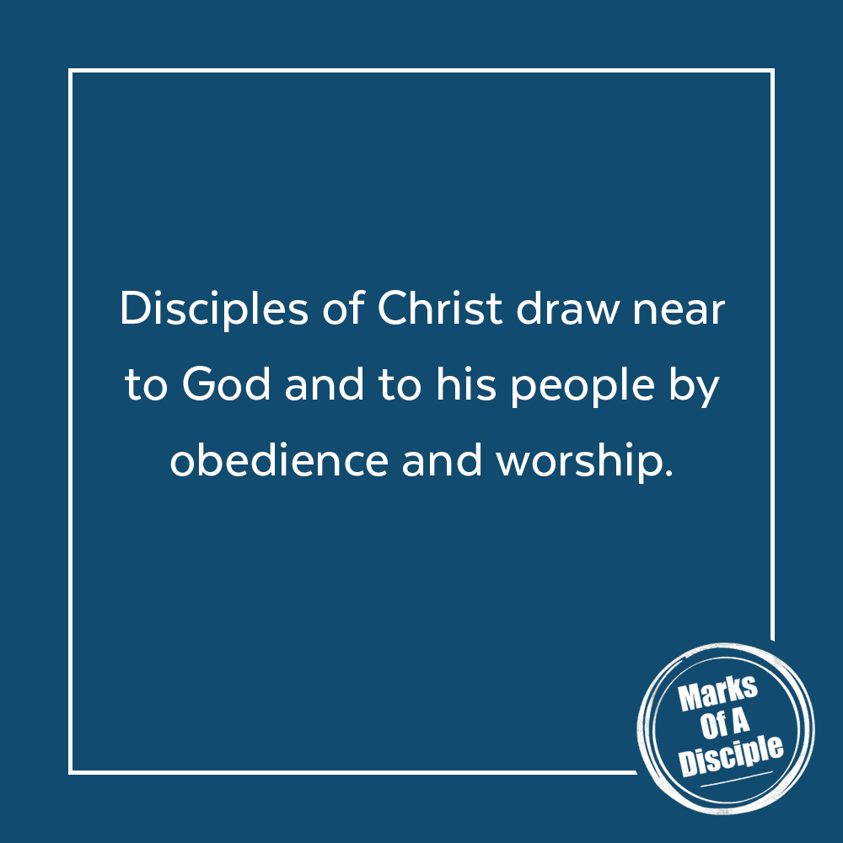

Scripture quotations are from the ESV® Bible (The Holy Bible, English Standard Version®), copyright ©2001 by Crossway, a publishing ministry of Good News Publishers. Used by permission. All rights reserved. May not copy or download more than 500 consecutive verses of the ESV Bible or more than one half of any book of the ESV Bible.
Any reference within this piece to Internet addresses of websites not under the​ ​administration of LeaderTreks is not to be taken as an endorsement of these​ ​websites by LeaderTreks;​ ​neither does LeaderTreks vouch for their content.

“Stone Soup,” Wikipedia, accessed May 1, 2020, https://en.wikipedia.org/w/index.php?title=Stone_Soup&oldid=953051775.
Watchman Nee, Sit, Walk, Stand: The Process of Christian Maturity (Fort Washington, PA: CLC Publications, 2009).

