WHAT THE BIBLE HAS TO SAY ABOUT IT

Notes:
_____________________________________________________________________________________________________
_____________________________________________________________________________________________________
_____________________________________________________________________________________________________
_____________________________________________________________________________________________________
_____________________________________________________________________________________________________
_____________________________________________________________________________________________________

THE BIBLE IN YOUR LIFE
Read Luke 10:38–42 and Psalm 127:1–2, then answer the following questions.
Answer:
On a scale of 1–4 (4=extremely busy), how would you rate your level of busyness?

How does your busyness affect your relationship with Jesus?

In Luke 10:42, Jesus says, “one thing is necessary.” What is that one thing?

If you could cut out one or two things from your life, what would they be and why?

APPLY IT  Busyness is a choice. Whenever your busy life comes between you and Jesus, it’s up to you to set your priorities and follow through. This week, try and identify the busy things in your life that push out Jesus. How can you adapt your schedule and responsibilities to better prioritize your faith? | Be specific:  What are you going to do?  When are you going to do it?  Is there someone who can keep you accountable?

PRAYER
Take time to pray for each other’s application steps in the upcoming weeks.

THE TAKEAWAY
Busyness can cause us to miss out on a real relationship with God.

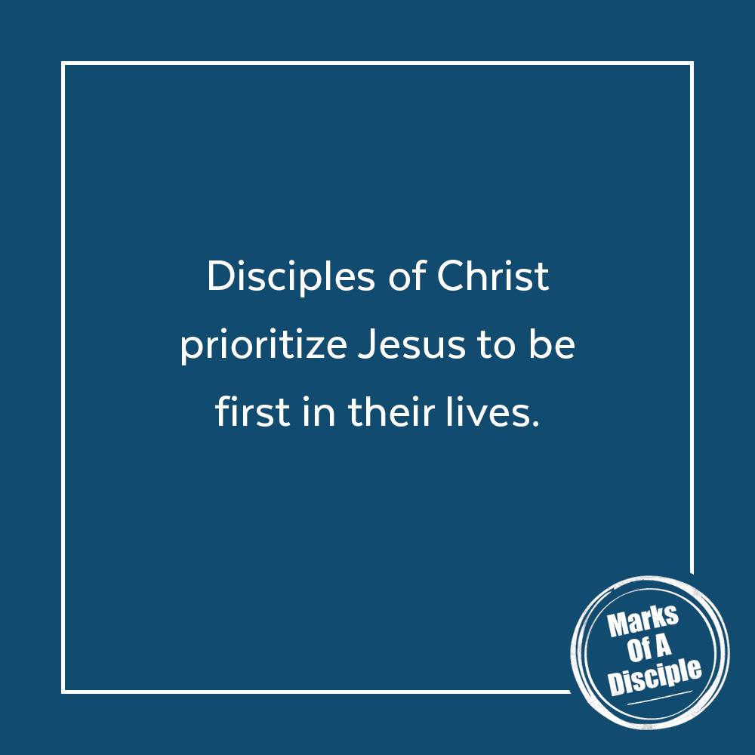
MEMORY VERSE
“But one thing is necessary. Mary has chosen the good portion, which will not be taken away from her.”
Luke 10:42 (ESV)
A QUOTE TO THINK ABOUT
“However, if I were to let my life be taken over by what is urgent, I might very well never get around to what is essential. It's so easy to spend your whole time being preoccupied with urgent matters and never starting to live, really live.”
– Henri Nouwen

