WHAT THE BIBLE HAS TO SAY ABOUT IT

Notes:
_____________________________________________________________________________________________________
_____________________________________________________________________________________________________
_____________________________________________________________________________________________________
_____________________________________________________________________________________________________
_____________________________________________________________________________________________________
_____________________________________________________________________________________________________

THE BIBLE IN YOUR LIFE
Read Romans 6:1–23, then answer the following questions.

Answer:
What is the outcome of being a slave to sin versus being a slave to righteousness?

Is it possible to both follow Jesus and still actively sin? Why or why not?

Do you have sin in your life you haven’t given over to God yet? What are you going to do about it?

How does knowing that God rescued you from a life of slavery to sin help you in your obedience?

APPLY IT  In John 8, Jesus tells a woman “go and sin no more.” This wasn’t a suggestion—it was a command. Jesus gives us the same command when we find new life in him: sin no more. Identify a sin that you struggle with and make a specific plan for what to do each time you are tempted to sin in that area. This might include texting a friend and asking for prayer, reading a Psalm, reciting a helpful Bible verse, or praying through it. | Be specific:  What are you going to do?  When are you going to do it?  Is there someone who can keep you accountable?

PRAYER
Take time to pray for each other’s application steps in the upcoming weeks.

THE TAKEAWAY
Christ has saved us from our slavery to sin. If we think we can continue to sin
because God has grace, we don’t really understand grace.

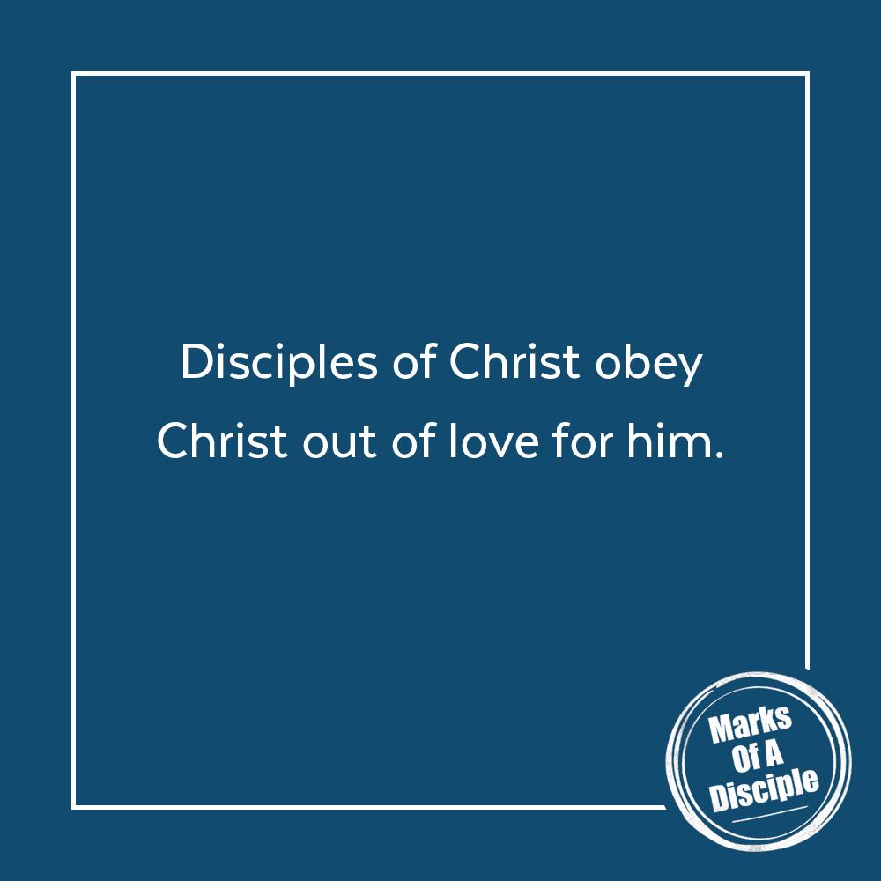
MEMORY VERSE
“What shall we say then? Are we to continue in sin that grace may abound? By no means! How can we who died to sin still live in it?”
Romans 6:1–2 (ESV)
A QUOTE TO THINK ABOUT
“For grace is given not because we have done good works, but in order that we may be able to do them.”
– St. Augustine

