WHAT THE BIBLE HAS TO SAY ABOUT IT

Notes:
_____________________________________________________________________________________________________
_____________________________________________________________________________________________________
_____________________________________________________________________________________________________
_____________________________________________________________________________________________________
_____________________________________________________________________________________________________
_____________________________________________________________________________________________________

THE BIBLE IN YOUR LIFE
Read Isaiah 9:1–7, then answer the following questions.

Answer:
How do you see God reaching out in love, grace, and forgiveness to his unfaithful people in this passage?

What do prophecies like this show us about God?

Where in your life do you feel like you’re walking in darkness?

How has Jesus entered your world to shed light on your life?
APPLY IT  When we realize the bigger, eternal story of God’s pursuit of his people—and that he’s invited us to be in his family—we praise him for his love and faithfulness. Think of a specific way you can praise God for his loving pursuit of you this week. | Be specific:  What are you going to do?  When are you going to do it?  Is there someone who can keep you accountable?

PRAYER
Take time to pray for each other’s application steps in the upcoming weeks.

THE TAKEAWAY
God’s plan of salvation was intentionally planned out and prophesied
thousands of years before Jesus came to Earth.

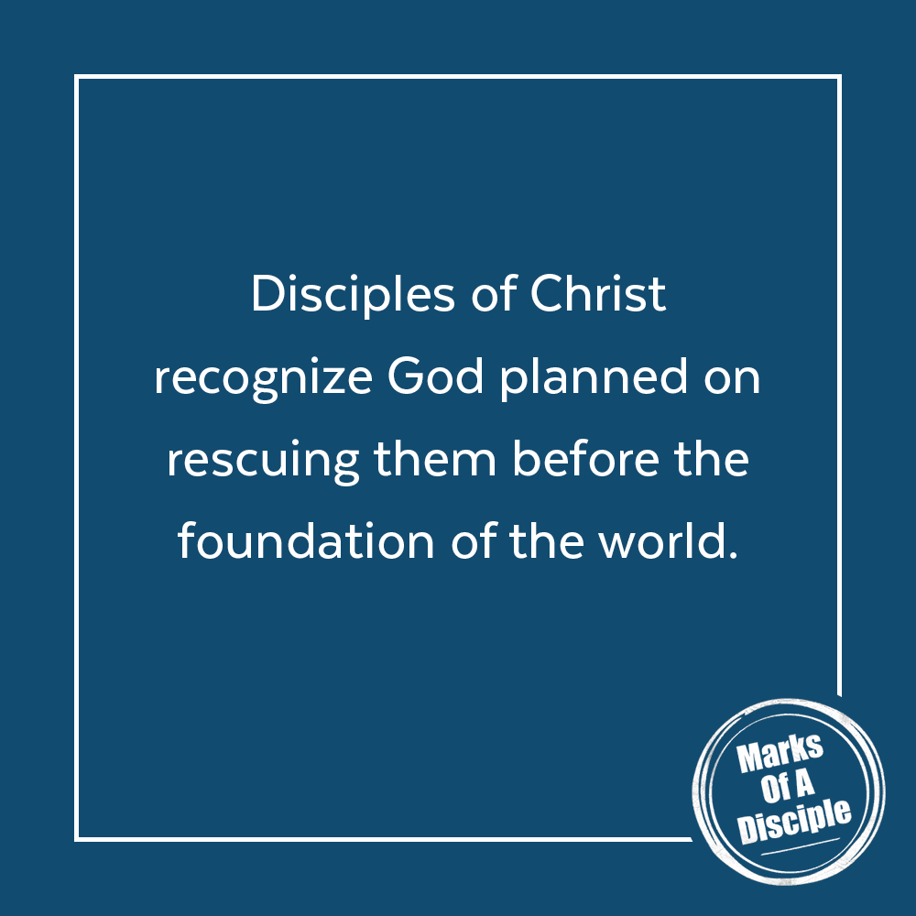
MEMORY VERSE
“For to us a child is born, to us a son is given; and the government shall be upon his shoulder, and his name shall be called Wonderful Counselor, Mighty God, Everlasting Father, Prince of Peace.”
Isaiah 9:6 (ESV)
A QUOTE TO THINK ABOUT
“The true Son left his home with the Father and went to the cross so that we who had run from the Father could be welcomed as sons.” – Trevor Laurence

