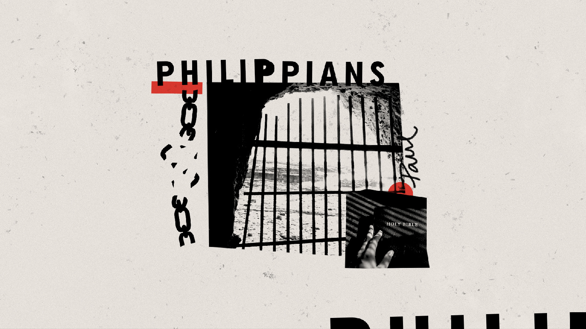
SMALL GROUP GUIDE
NO CONFIDENCE & FOLLOW PAUL
Small Group Guide | No Confidence &
1

CONTEXT– HEART
Give students space to think about anything they do, believing that it makes them right before God.

We want them to walk away free from the burden of works being something that saves them. Their debt is paid in full by faith. They can rest in this.

QUESTIONS TO ASK YOUR STUDENTS - HEART
- Is there anything you do that you believe makes you right before God? How so?
- Is your life focused on Christ? How so?
- Is there anything you are trying to earn from God? How so?

APPLICATION – HANDS
Challenge students to read the book of Galatians where Paul lays out his explanation of why works are not a part of salvation.

